
National University of Sciences & Technology (NUST) Balochistan Campus (NBC), Department of Computer Science
Department of Computing
CS-250: Data Structure and Algorithms
Class: BSCS
Lab 1: Implementation of pointers and dynamic memory allocation
Date: 11 September, 2024
Time: 10-1pm

NAME | Sameer Talreja
CMS ID | 457795
DEPARTMENT | BS CS
SEMESTER | 3rd

CS250: Data Structures and Algorithms Page 1

National University of Sciences & Technology (NUST) Balochistan Campus (NBC), Department of Computer Science
Lab 1: Implementation of pointers and dynamic memory allocation
Introduction
This lab is about the pointers and memory occupied by the data variables.
Objectives
This lab will revise the old concepts of the students, taught in the previous semesters.
Tools/Software Requirement
Visual Studio C++ , DevCpp, Visual Studio code
Description
Pointers are used to point towards a particular memory address. In this lab we will use the pointers and perform task with the help of them also we are using 2D arrays and Search in array. Other than this we will revise the concepts of inheritance; concept previously studied in OOP; and will create a small, very basic application.
Lab Tasks
You are required to upload the lab tasks on Google Classroom and the name of that tasks must be in this format YourFullName_reg#.cpp
Remember to comment your code properly. Inappropriate or no comment will result in deduction of marks.
CS250: Data Structures and Algorithms Page 2

National University of Sciences & Technology (NUST) Balochistan Campus (NBC), Department of Computer Science
Tasks 1;
Create a struct named “Contact” that represents a contact in a contact list. Each contact should have:
• name (a std::string to store the contact's name)
• phoneNumber (a std::string to store the contact's phone number)
Then, create a struct named “ContactList” that manages an array of Contact structs. This ContactList struct should include:
• A pointer to an array of Contact structs
• An integer to track the number of contacts in the list
• An integer to represent the maximum capacity of the list
Provide functions to:
1. Add a new contact to the list
2. Print all contacts in the list
Requirements:
• Use pointers for dynamic memory management.

#include <iostream>
#include <string>

using namespace std;

struct Contact {
string name;
string phoneNumber;
};

struct ContactList {
Contact* contacts;
int currentSize;
int maxSize;
};

// Function to add a new contact to the list
void addContact(ContactList &list, const string &name, const string &phoneNumber) {
if (list.currentSize == list.maxSize) {
cout << "Contact list is full" << endl;
return;
}
// Add new contact to the list
list.contacts[list.currentSize].name = name;
list.contacts[list.currentSize].phoneNumber = phoneNumber;
list.currentSize++;
}

// Function to print all contacts in the list
void printContacts(const ContactList &list) {
for (int i = 0; i < list.currentSize; i++) {
cout << "Contact " << i + 1 << ": " << endl;
cout << "Name: " << list.contacts[i].name << endl;
cout << "Phone Number: " << list.contacts[i].phoneNumber << endl;
}
}

int main() {
// Initialize the contact list
int maxSize;
cout << "Enter the maximum number of contacts you want to store: ";
cin >> maxSize;

ContactList list;
list.contacts = new Contact[maxSize]; // Dynamically allocate memory for the contact list
list.currentSize = 0;
list.maxSize = maxSize;

// Variable to store user input
string name, phoneNumber;
char choice;

// Adding contacts from the user
do {
cout << "\nEnter contact name: ";
cin.ignore(); // This is to clear any leftover newline character from previous input
getline(cin, name);

cout << "Enter contact phone number: ";
getline(cin, phoneNumber);

// Add contact to the list
addContact(list, name, phoneNumber);

// Ask if the user wants to add another contact
cout << "Do you want to add another contact? (y/n): ";
cin >> choice;

} while (choice == 'y' || choice == 'Y');

// Print all contacts
cout << "\n--- Contact List ---" << endl;
printContacts(list);

// Free dynamically allocated memory
delete[] list.contacts;

return 0;
}

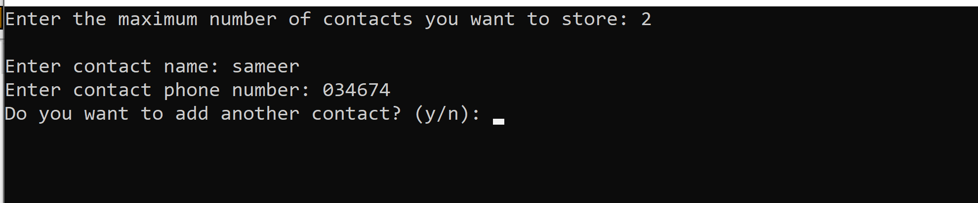
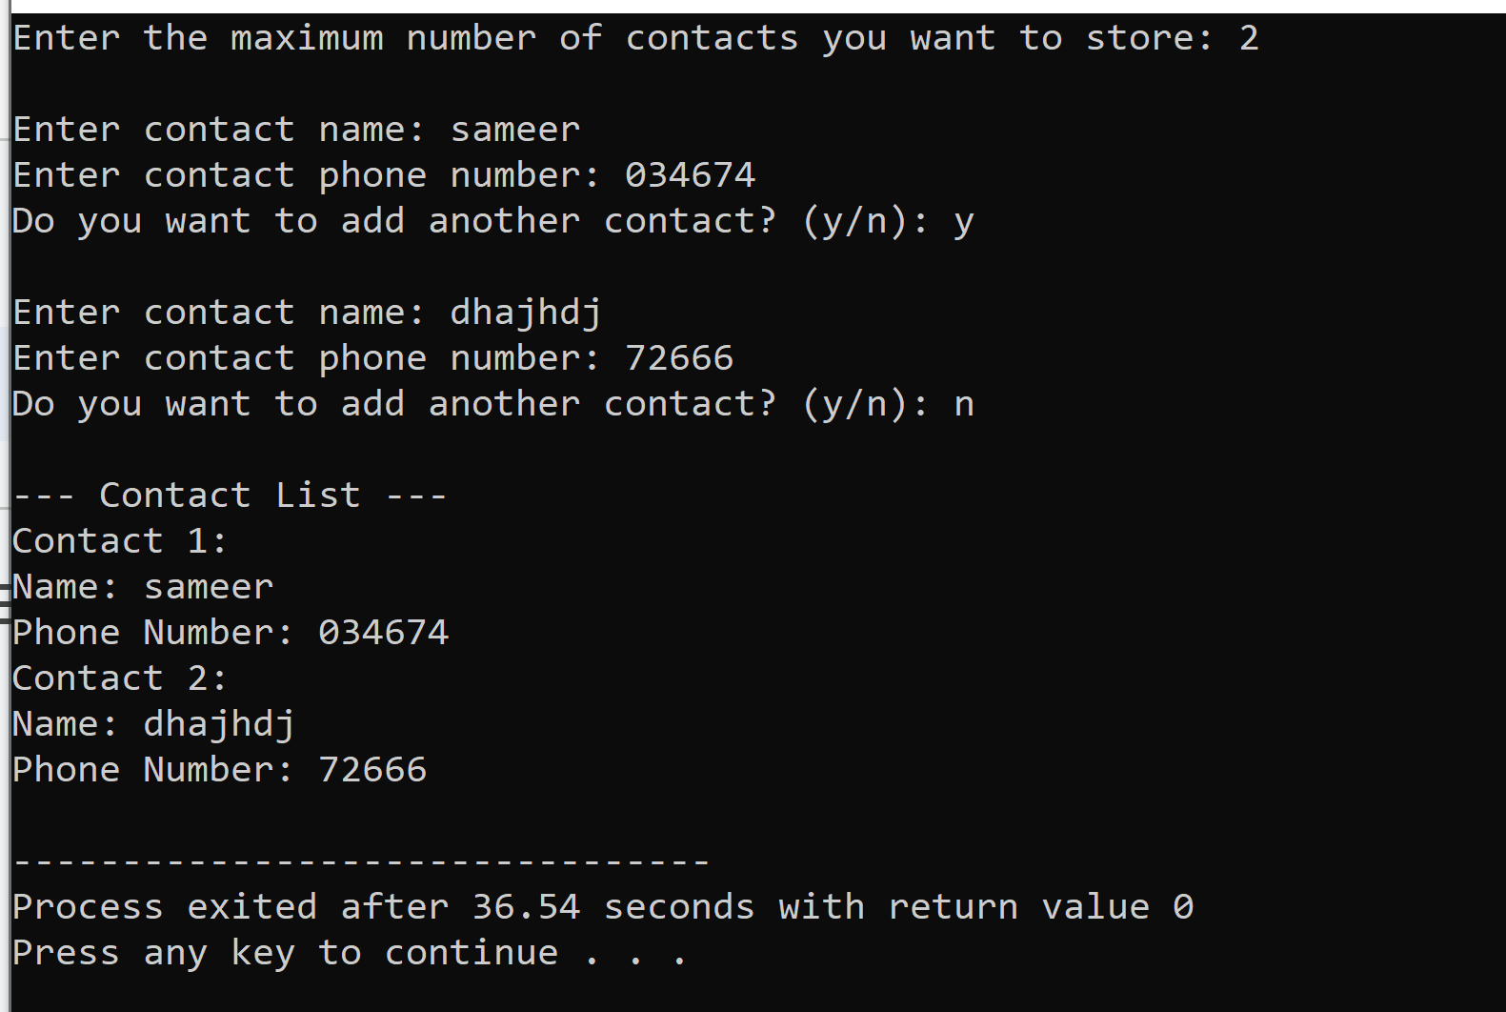

Tasks 2;
Create a class “DynamicArray” that manages a dynamic array of integers. The class should include the following methods:
1. A constructor that takes the size of the array and initializes it with default values. 2. A destructor to release the allocated memory.
3. A method to set a value at a specific index.
4. A method to get the value at a specific index.
5. A method to print all values in the array.

#include<iostream>
using namespace std;

class dynamicArr {
private:
int size;
int **arr;
public:

//constructor to allocate the memory
dynamicArr(int s) {
size = s;
arr = new int*[size];
for (int i = 0; i < size; i++) {
arr[i] = new int[size];
arr[i][0] = 0;
}
}
// destructor to deallocate the memory
~dynamicArr() {
delete[] arr;

}
//method to set a value at specific index
void setValue(int index, int value) {
if (index >= size || index < 0) {
cout << "Invalid index: " << index << endl;
} else {
arr[index][0] = value;
}
}
//method to get a value at specific index
int getValue(int index) {
if (index >= 0 && index < size) {
return arr[index][0];
} else {
cout << "Index out of bounds." << endl;
return -1;
}
}
//method to print all the values in the array
void print() {
for (int i = 0; i < size; i++) {
cout << arr[i][0] << " ";
}
cout << endl;
}
};
int main() {
dynamicArr Arr(5);
Arr.setValue(0, 2);
Arr.setValue(1, 4);
Arr.setValue(2, 6);
Arr.setValue(3, 8);
Arr.setValue(4, 15);
cout << "Values have been set in the array at the specified indices." << endl;
Arr.print();

int index;
cout << "Enter the index to retrieve the value: ";
cin >> index;
int value = Arr.getValue(index);
if (value != -1) {
cout << "The value at index " << index << " is " << value << endl;
}
return 0;
}

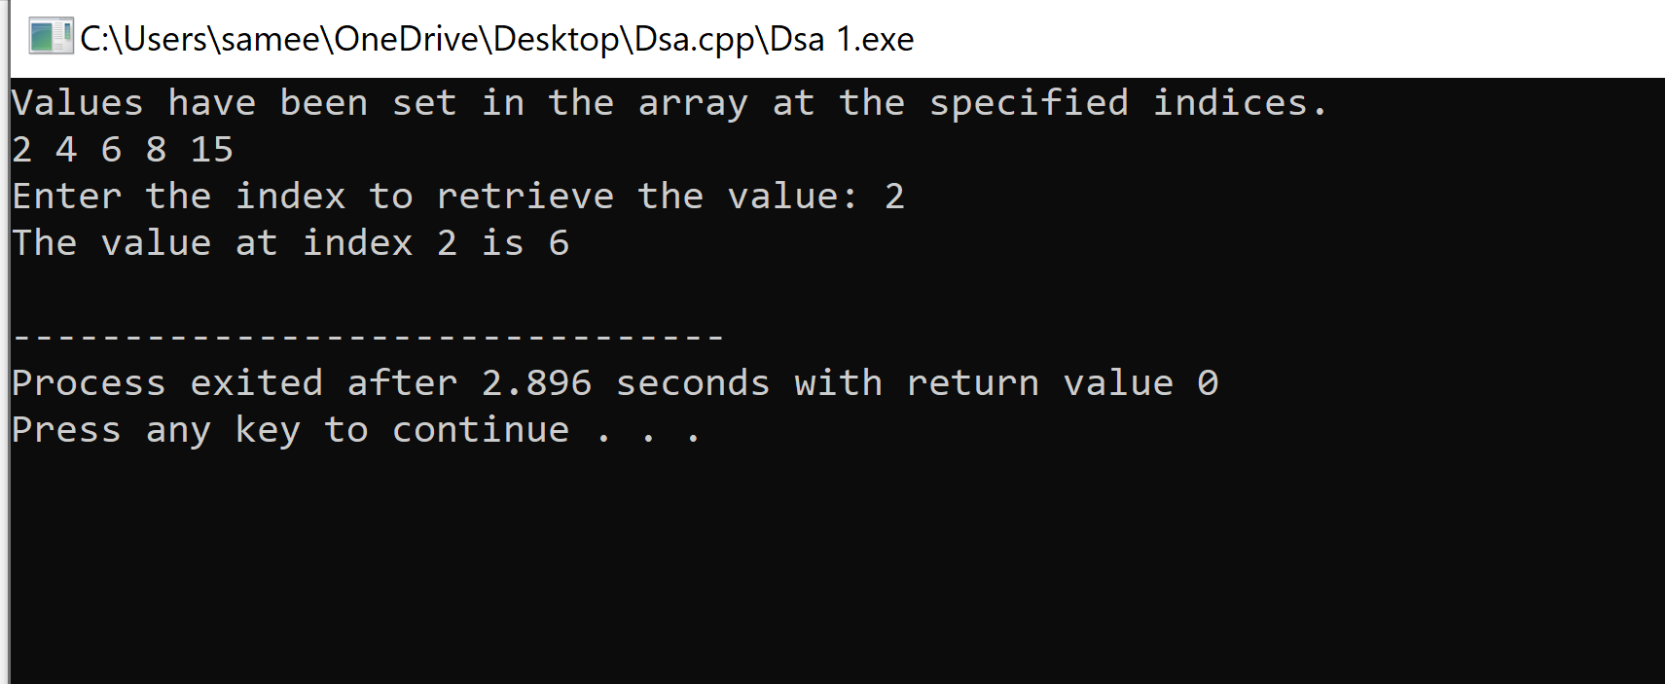
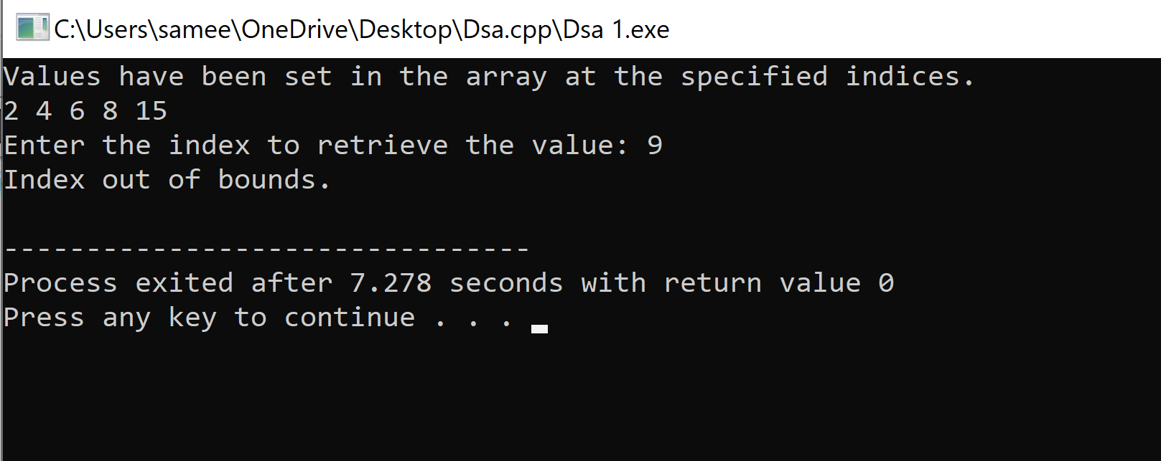

CS250: Data Structures and Algorithms Page 3

National University of Sciences & Technology (NUST) Balochistan Campus (NBC), Department of Computer Science
Requirements:
• Use pointers to manage the dynamic array.
• Use a pointer-to-pointer for initializing and managing the array in the constructor.
Tasks 3;
Create a class “CharGrid” that represents a 2D grid of characters. The class should include the following methods:
1. A constructor to initialize the grid with a given number of rows and columns, and to allocate memory dynamically.
2. A destructor to release the allocated memory.
3. A method to set a character at a specific position (row, col).
4. A method to get a character from a specific position (row, col).
5. A method to print the entire grid.
Requirements:
• Use pointers and pointer-to-pointer to manage the 2D character grid.
• Implement the string search functionality without using C string functions (i.e., strcmp, strstr, etc.).

#include<iostream>
using namespace std;

class charGrid {
private:
int row;
int column;
char **grid;

public:
//A constructor to initialize the grid with a given number of rows and columns, and to allocate memory dynamically.
charGrid(int r, int c) {
row = r;
column = c;

grid = new char*[row];
for (int i = 0; i < row; i++) {
grid[i] = new char[column];
}
for (int i = 0; i < row; i++) {
for (int j = 0; j < column; j++) {
grid[i][j] = ' ';
}
}
}
// A destructor to release the allocated memory.
~charGrid() {
for (int i = 0; i < row; i++) {
delete[] grid[i];
}
delete[] grid;
}

// A method to print the entire grid.
void print() {
for (int i = 0; i < row; i++) {
for (int j = 0; j < column; j++) {
cout << grid[i][j] << " ";
}
cout << endl;
}
}
//. A method to set a character at a specific position (row, col).
void SetChar(int r, int c, char ch) {
if (r >= 0 && r < row && c >= 0 && c < column) {
grid[r][c] = ch;
} else {
cout << "Invalid position!" << endl;
}
}
// A method to get a character from a specific position (row, col).
char getChar(int r, int c) {
if (r >= 0 && r < row && c >= 0 && c < column) {
return grid[r][c];
} else {
cout << "Invalid position!" << endl;
return '\0';

}
}
};

int main() {
charGrid obj(4, 4);
obj.SetChar(0, 0, 'S');
obj.SetChar(0, 1, 'A');
obj.SetChar(0, 2, 'M');
obj.SetChar(0, 3, 'E');
obj.SetChar(1, 0, 'E');
obj.SetChar(2, 0, 'R');
char p = obj.getChar(0, 1);
char p1 = obj.getChar(2, 2);
cout << "Character at (0,1): " << p << endl;
cout << "Character at (2,2): " << p1 << endl;
obj.print();
return 0;
}

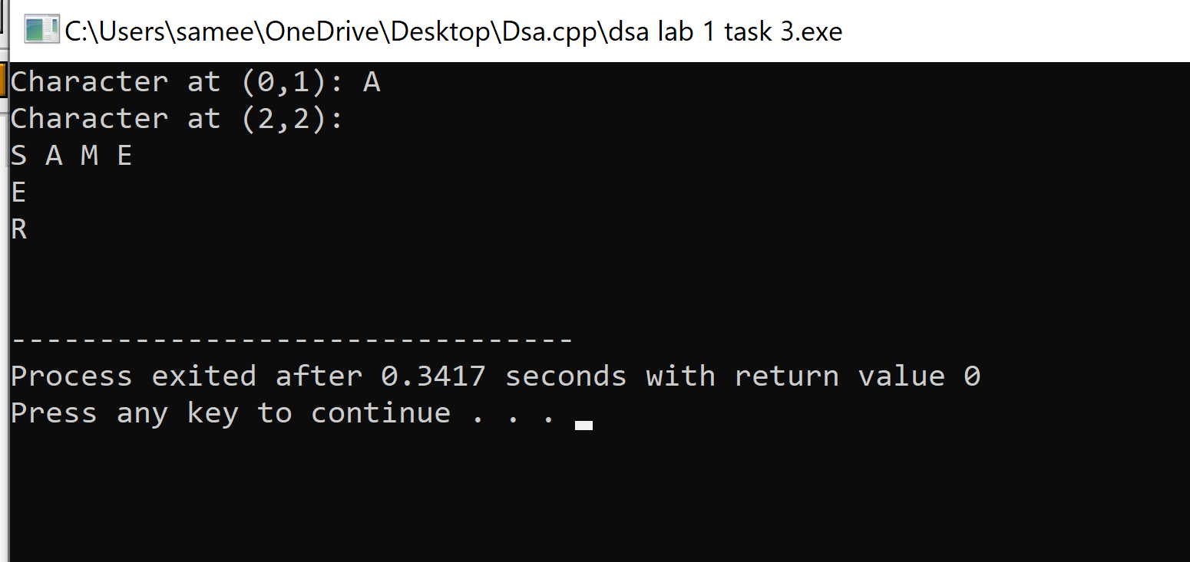

Deliverables
Compile a single word document by filling in the solution part and submit this Word file on LMS. This lab grading policy is as follows: The lab is graded between 0 to 10 marks. The submitted solution can get a maximum of 5 marks. At the end of each lab or in the next lab, there will be a viva related to the tasks. The viva has a weightage of 5 marks. Insert the solution/answer in this document. You must show the implementation of the tasks in the designing tool, along with your complete Word document to get your work graded. You must also submit this Word document on the LMS. In case of any problems with submissions on LMS, submit your Lab assignments by emailing it to Mr. Safder Ali: students.em96@gmail.com .
CS250: Data Structures and Algorithms Page 4

